 | ~ January 2018 ~
Sun | Mon | Tue | Wed | Thu | Fri | Sat
 | 1  Happy NEW YEAR | 2  4:30p Hatha  6:00p Beginner’s Yoga | 3  9:00a Good Morning Yoga  5:00p Vinyasa Flow  6:15p CORE  7:30p Restorative | 4  4:30p Hatha  6:00p Beginner’s Yoga  7:30pm: Meditation @ THE WORKSHOP | 5  9:00a Good Morning Yoga  4:30pm Restorative  6:00pm Social Yoga | 6  9:00am Hatha  10:00am Roots of Yoga – Roseau, MN  11am-1pm Partner Yoga Workshop
7  5:00pm Somatics  6:45pm- Restorative | 8  9:00a Good Morning Yoga  5:00p Vinyasa Flow  6:15p Hatha  7:30p Restorative | 9  4:30p Hatha  6:00p Beginner’s Yoga  7:15pm Somatics | 10  9:00a Good Morning Yoga  5:00p Vinyasa Flow  6:15p CORE  7:30p Restorative | 11  4:30p Hatha  6:00p Beginner’s Yoga  7:15pm Somatics | 12  9:00a Good Morning Yoga  RTY200 In-Depth Study  4:00pm-10:00pm | 13  RTY200 In-Depth Study  8:00am-9:00pm  9:00am Hatha
14  RTY200 In-Depth Study  7:00am-3:00pm  5:00pm Somatics  6:45pm- Restorative | 15  9:00a Good Morning Yoga  5:00p Vinyasa Flow  6:15p Hatha  7:30p Restorative | 16  4:30p Hatha  6:00p Beginner’s Yoga  7:15pm Somatics | 17  9:00a Good Morning Yoga  5:00p Vinyasa Flow  6:15p CORE  7:30p Restorative | 18  4:30p Hatha  6:00p Beginner’s Yoga  7:15pm Somatics  7:30pm: Meditation @ THE WORKSHOP | 19  9:00a Good Morning Yoga  4:30pm Restorative  5:00pm Community Wellness Expo  6:30pm Social RUNNER’S Yoga | 20  9:00am Hatha  9am Community Wellness Expo
21  5:00pm Somatics  6:45pm- Restorative | 22  9:00a Good Morning Yoga  5:00p Vinyasa Flow  6:15p Hatha  7:30p Restorative | 23  4:30p Hatha  6:00p Beginner’s Yoga  7:15pm Somatics | 24  9:00a Good Morning Yoga  5:00p Vinyasa Flow  6:15p CORE  7:30p Restorative | 25  4:30p Hatha  6:00p Beginner’s Yoga  7:15pm Somatics | 26  9:00a Good Morning Yoga  4:30pm Restorative | 27  9:00am Hatha  OPEN HOUSE 11am-1pm
28  FREE Yoga ALL Day  10am: Vinyasa Flow  11:30: Hatha  1:00pm: Somatics  3:00pm: Restorative  4:15pm: Meditation | 29  9:00a Good Morning Yoga  5:00p Vinyasa Flow  6:15p Hatha  7:30p Restorative | 30  4:30p Hatha  6:00p Beginner’s Yoga  7:15pm Somatics | 31  9:00a Good Morning Yoga  5:00p Vinyasa Flow  6:15p CORE  7:30p Restorative

WORKSHOPS AND EVENTS

SOCIAL YOGA
Join us Friday, January 5th for one of our most popular yoga events: Social Yoga. Come for the yoga, stay for the spirits!

Each Month we, typically, host a Social Yoga event but this month we will have a bonus Social Yoga for those doing the Freeze Yer Gizzard Blizzard Run over Icebox Days Weekend. Join Whitney Junker for stretch and relaxation at Social, RUNNER’s Yoga on January 19th at 7pm.

Walk-ins Welcome
Pre-Register at www.replenishliving.com

Hatha
Join us for a class designed to be beginner friendly as well as adaptable for even the most advanced student. Hatha Yoga is one of the most popular and familiar yoga styles. Great for flexibility, strength, core and relaxation all in one!
Vinyasa
Smooth flowing and faster paced, which explains why it is sometimes referred to as “Flow”. This is a Level 1 or 2 class, some experience required.

Restorative Yoga
We quiet the mind, release the body and relax into a variety of restorative poses leaving the body renewed, refreshed, restored! A wonderful combination of well supported yoga and meditation. Beginner Friendly.
Somatics
Somatics yoga offers an incredibly subtle but effective way of working with the body, focusing on the use of small, slow and gentle movements to re-educate the brain, enabling us to relax and move these muscles more functionally
.

REPLENISH in January
ICEBOX DAYS WELLNESS EXPO: Icebox Days is an annual tradition of wacky ways to enjoy our Northern Minnesota Winter. Annually this event features the Freeze Yer Gizzard Blizzard Run which includes a Community Wellness Expo. You don’t want to miss this event! We’ll be giving away free classes, mats and so many more prizes to be WON! Join us Friday night and Saturday morning at Backus’ gymnasium.

OPEN HOUSE JANUARY 27th 11am-1pm: There have been many changes at the studio over the past few months. Most of these changes cannot be seen, but felt. Meet the new team, see ALL Replenish has to offer. We aren’t just yoga classes. We teach instructors, meditation, practice kindness and even sell retail items directly from India! Stop in for a FREE, authentic lunch and the chance to WIN!

FREE CLASSES!!! JANUARY 28th ALL DAY!!
Come to one or all. We invite you to try any of our classes for free. Each full class will feature the weekly instructor and give you an idea of what to expect in the classes available at Replenish Studio.

Meditation with Christa
at The Workshop, 323 3rd Street, Int'l Falls

The best meditation is the kind that works for you, wherever you are in your life.

Christa will guide you on how to quiet your mind with simple practices and tips you can take with you into your everyday life. 1st and 3rd Thursday of the month starting September 21.
We want to hear from you ~

Not seeing a class, yoga style or event you are interested in? Without YOU, there is no US. Please reach out to us for feedback, concerns, kudos and thoughts. Your input helps us create a growing yoga experience reflective of our cherished students.
We are ever so grateful ~
Email: replenishliving@gmail.com
Or Find us on:

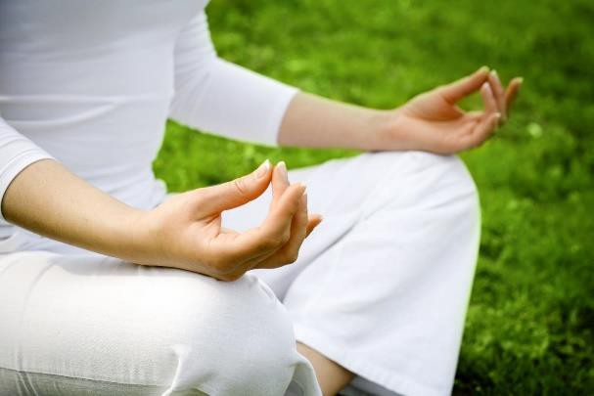

Replenish Living
900 5th Street – Suite 303
International Falls, MN 56649
(218) 286-4006
replenishliving@gmail.com
www.replenishliving.com
“Most people have no idea
how good
their body is designed to feel”

