 | ~ October 2017 ~
Sun | Mon | Tue | Wed | Thu | Fri | Sat
1  5:30p Men’s Yoga  6:45p Restorative Yoga | 2  9:00a Hatha  5:00p Vinyasa Flow  6:15p CORE | 3  4:30p Hatha | 4  9:00a Hatha  5:00p Vinyasa Flow  6:15p CORE | 5  4:30p Hatha  7:30pm: Meditation @ THE WORKSHOP | 6 | 7  9:00a Hatha
8  5:30p Men’s Yoga  6:45p Restorative Yoga | 9  9:00a Hatha  5:00p Vinyasa Flow  6:15p CORE | 10  4:30p Hatha | 11  9:00a Hatha  5:00p Vinyasa Flow  6:15p CORE | 12  4:30p Hatha | 13  5:30-7PM  SOMA YOGA CLASS | 14  9:00-11:30am  SOMA YOGA WORKSHOP
15  11:00am-12:30pm LOVING KINDNESS MEDITATION  5:30p Men’s Yoga  6:45p Restorative Yoga | 16  9:00a Hatha  5:00p Vinyasa Flow  6:15p CORE | 17  4:30p Hatha | 18  9:00a Hatha  5:00p Vinyasa Flow  6:15p CORE | 19  4:30p Hatha  7:30pm: Meditation @ THE WORKSHOP | 20 | 21  9:00a Hatha
22  5:30p Men’s Yoga  6:45p Restorative Yoga | 23  9:00a Hatha  5:00p Vinyasa Flow  6:15p CORE | 24  4:30p Hatha | 25  9:00a Hatha  5:00p Vinyasa Flow  6:15p CORE | 26  4:30p Hatha | 27 | 28  9:00a Hatha  11am-12:30pm BEGINNERS YOGA WORKSHOP
29  11am FAMILY YOGA  5:30p Men’s Yoga  6:45p Restorative Yoga | 30  9:00a Hatha  5:00p Vinyasa Flow  6:15p CORE | 31  4:30p Hatha

WALK-IN’S WELCOME

Hatha
Join us for a class designed to be beginner friendly but allows for pose and level options that even the most advanced student will benefit from. Great for flexibility, strength, Core and relaxation all in one!

Vinyasa Flow
Vinyasa movements are smoothly flowing and faster paced, which explains why it is sometimes referred to as Vinyasa Flow. This is a Level 1 or 2 class, some experience required.

Restorative Yoga
We quiet the mind, release the body and relax into a variety of restorative poses leaving the body renewed, refreshed, restored! A wonderful combination of yoga and meditation. Beginner Friendly!

Men’s Yoga
A class specifically for Men – and taught by a man!! A gentle practice to move and stretch the body regardless of your current flexibility. Classes will teach basic yoga poses and sequences. Although designed for the beginner – all levels of experience are welcome!!

WORKSHOPS AND EVENTS

Soma Yoga Workshops
Friday, October 13 from 5:30 - 7:00 p.m.
Soma Yoga Class
Saturday, October 14 from 9:00 – 11:30 a.m.
Soma Yoga Workshop
Sunday, October 15 from 11:00 a.m. – 12:30 p.m. : Loving Kindness Meditation
Join guest instructor Angela Fulghum of Nomad Wellness for Soma Yoga. By strengthening the mind/body connection, Soma (the Greek word for living body) Yoga encourages functional and free movement in our beings, reconnecting us with the inherent state in which we are meant to live. By increasing the function and ease of the soma, pain releases, as well as chronic habits that cause disease in our bodies.
Beginner's Yoga Workshop
Saturday, October 28 from 11 a.m. – 12:30 p.m.
Discover the practice that 36 million Americans enjoy with a class designed for the curious. We’ll cover the basics – alignment, breathing and poses – so you can discover the benefits of this ancient tradition.
Family Yoga Workshop
Sunday, October 29 from 11 a.m. – 12:30 p.m.
No hockey, homework, iPads or housework allowed, just each other. Strengthen the bonds that connect you – parent to child, grandparent to grandchild – while having fun in a safe, encouraging environment.

Meditation with Christa
at The Workshop, 323 3rd Street, Int'l Falls

The best meditation is the kind that works for you, wherever you are in your life.

Christa will guide you on how to quiet your mind with simple practices and tips you can take with you into your everyday life. 1st and 3rd Thursday of the month starting September 21.

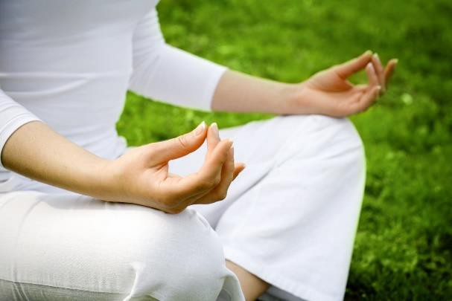

Replenish Living
900 5th Street – Suite 303
International Falls, MN 56649
(218) 286-4006
replenishliving@gmail.com

www.replenishliving.com

